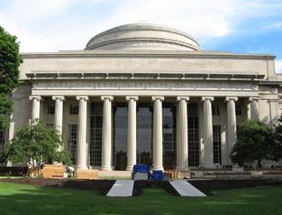
RMW20

The 20th Workshop on Reactive Metal Processing
March 19 (Fri.) – 20 (Sat.), 2027 @ MIT, Cambridge
(After TMS 2027, March 14 (Sun.) – 18 (Thu.), 2027 @ Orlando, Florida)

Organizers:
Donald R. Sadoway, Massachusetts Institute of Technology
Toru H. Okabe, Institute of Industrial Science (IIS),
The University of Tokyo
Antoine Allanore, Massachusetts Institute of Technology
Shunsuke Yagi IIS, The University of Tokyo

Program Coordinators:
Taka Narumi, IIS, The University of Tokyo
Lucas Marden, Massachusetts Institute of Technology
Isaac Oda-Bayliss, IIS, The University of Tokyo
Matthew Michalek, Massachusetts Institute of Technology
Takumi Kaneko IIS, The University of Tokyo

Sponsors
- The Rare Metal Research Workshop, one of the Special Research Groups organized by the Foundation for the Promotion of Industrial Science (FPIS)
(RC-40: directed by Prof. T. H. Okabe, RC-104: directed by Prof. S. Yagi)
- Research Center for Sustainable Material Energy Integration (SUSMAT)
- Institute of Industrial Science, The University of Tokyo (IIS UTokyo SYMPOSIUM No 135)
http://www.okabe.iis.u-tokyo.ac.jp/core-to-core/rmw

